Hoof foto van die bakkies en die hele span

Welcome to Witkop Hunting Safaris

We offer plains game and dangerous game hunting, with a variety of hunting packages across South – Africa, designed for an exceptional hunting experience. We practice ethical hunting techniques at all times. Through selective hunting these areas always produce good quality trophy animals.

The bushveld around the Springbok flats in the Limpopo makes for a memorable hunting destination with a variety of game such as Impala, Blesbuck, Red hartebeest, Blue wildebeest, Zebra, Sable, Nyala, Kudu, Cape Buffalo and so much more. ( Foto van twee Sable bulle, en dalk koedoe bulle )

Our game farm with its breathtaking sunrise & sunsets, surrounded by beautiful marula trees, makes for a truly beautiful landscape in the bushveld. (foto van sonopkoms met geweer in linker hoek)

We offer tours to two of the most beautiful sceneries in South Africa, The Garden Route and The Kruger National Park, there are also other activities available, like Adventure with Elephants, Crocodile tour and feedings, Zipline and Eventiera wildlife park, etc.

Come and enjoy this magnificent bushveld and have a once in a life time African hunting experience. I Wessel van der Walt, Hunting Outfitter and Professional Hunter will personally guide you on your hunting expedition, and I ensure you will enjoy it with much pleasure and unforgettable memories.

Our team are well trained and skilled in their respective fields and they contribute enormously in the day to day operations of Witkop Hunting Safaris. With their respect and friendliness, they create a pleasant atmosphere and working environment,

This is where the safari starts and friends are made, become part of the adventure and book with us.

**Our History**

My passion for hunting in this beautiful bushveld and the wildlife thereof, started with my father “Barefoot Teunis” a farmer and an exceptional hunter, my Idol, living in the bushveld on the edge of the springbok flats near Tuinplaas Limpopo.

My father is a phenomenal stalker in the bush, because he never wares shoes, his feet are as tuff as an elephant hide, soundless through the veld. My favorite hunting story of his, is when he stalked and finally shot this elusive big male leopard that was killing most his cattle and calves for months. (Foto van Teunis met leopard, naam Theunis van der Walt 1982).

The first time my father took me out hunting was in the summer of 1998 on the farm Mackenzie, where we stalked bush pigs eating in our corn fields, bush pigs are master destroyers of corn fields in South Africa. On the stalk around and through the corn, “Barefoot” stopped me and whispered softly, Make ready” he places the rifle on his shoulder and told me “take him when you are ready”. I took the shot and killed my first bush pig at the age of 5 years old, truly a day to remember with my father, and I am grateful for him putting me on the right path to my professional hunter and outfitter career. (Foto van Wessel met bosvark)

(Fotos van al die ou dae se jag, Wessel rooibok, waterbok, gembok en Oom teunis Waterbok en bosbok)

In 2014 I met my wife Mellissa and fell head over heels for her, she is a fine huntress and fishing enthusiast, right in my line of work. “Love her very much”. In 2015 she helped me to build and develop our game farm and hunting camp. We opened our hunting business Witkop Hunting Safaris 2016 and it is our dream and passion every day. We started hunting with South African biltong hunters and gained much experience and friends along the way, but there was still something missing… Our big dream was about to came true, bringing clientele from all over the world, to hunt and experience South Africa and all nature can offer to our farm Witkop Hunting Safaris.

We are looking forward to meet you, and become friends to guide you through your dream hunting adventure.

Witkop Hunting Safaris, since 2016.

Be tough, THIS IS AFRICA.

**Our team:**

Chief in charge

“I will guide you personally on a truly beautiful African hunting adventurer of a lifetime”.

Hunting Outfitter & FOTO

Professional Hunter

Wessel van der Walt

Hunting camp Administrator FOTO

Chieftess

“Making your stay with us unforgettable, with comfort and African cuisine”.

Chef, manager

Mellissa van der Walt

Profession domestic FOTO

“Like early morning blossoms, our rooms and camp facilities, will be clean and fresh. I take pride in my work”.

Cleaner and servant

Welhemina Moloisane

Professional head skinner FOTO

“I’m a jack of all trade”.

and Tracker, camp maintenance

Piet Masetloa

Gardner, assistant skinner FOTO

“I’m a jack of all trade in training”.

and tracker

Maxwel Masunda

“I’ll do my best to assist and find your trophy animal”.

Professional tracking friend FOTO

Jakkals

**Other information**

**Taxidermist**

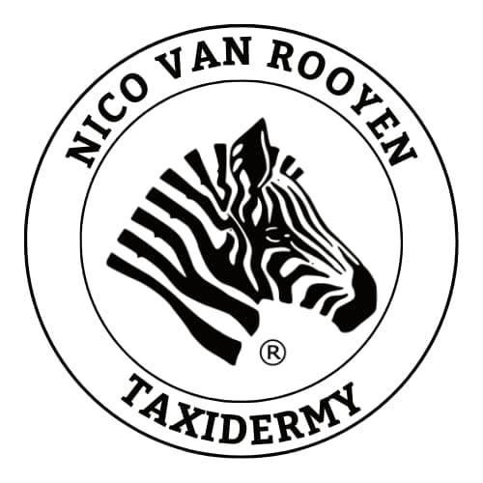Taxidermy with Witkop Hunting Safaris is as important to us as it is to you. We know the importance of having that trophy against your wall and that life size memory in your living room.

We highly recommend Nico van Rooyen Taxidermy.

They have been the choice of some of the world’s top sport

hunters year after year. No project is too large or too small.

Action and custom mounts are there specialty.

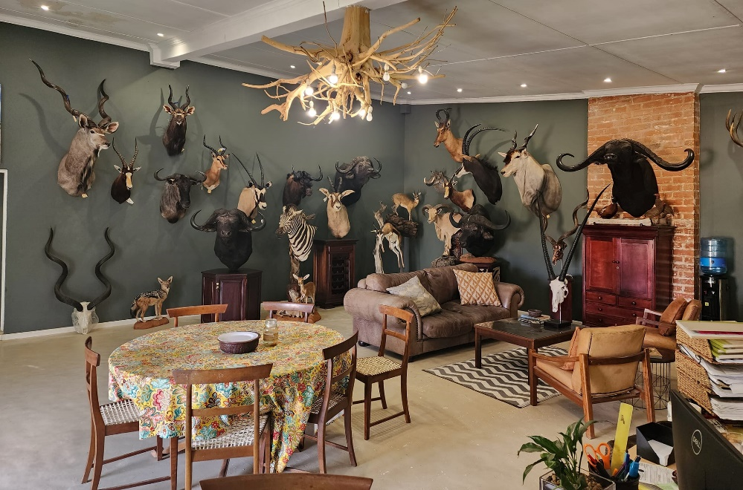

**Safari Contract (Sal dokument opstel het voorbeeld van een)**

Before embarking on your safari, it’s important to review and fill in our Safari Contract.

This document outlines the terms, responsibilities and expectation for both parties to ensure a smooth and enjoyable safari experience.

Download

**SAPS Forms ( Sal vorm vir jou aanstuur)**

If you intend to bring your own firearm on this hunting adventure, you will need to complete the necessary SAPS forms for temporary firearm importation.

Download and follow the instructions carefully to ensure compliance with the firearm regulations.

**CBD Forms (Sal vorm vir jou aanstuur)**

For your international journey with personal effects, including firearms and valuable items, it’s crucial to obtain a Certificate of Registration. This document serves as official proof of ownership and can significantly simplify customs procedures.

Download and complete to ensure a hassle-free travel experience.

**Gallery**

Alle jag fotos en akkomodasie en wild natuurlik

**Contact information**

Witkop Hunting Safaris, Waterberg district, Limpopo, South Africa.

Wessel van der Walt

072 200 3229

Mellissa van der Walt

082 569 6508

Email:

[witkophuntingsafaris@gmail.com](mailto:witkophuntingsafaris@gmail.com) of nuwe een

Explore us

Facebook link Instagram link Twitter link